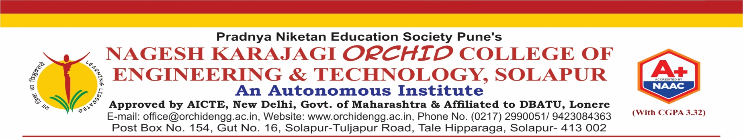
Department of AI&DS
HACKATHON APPLICATION FORM

Name of the Event: Code Rush 1.0
Date of the Event: 22/08/2025
Organized by: YCCE Nagpur

Participant Details
- Full Name of Participant: Pritik Kumar Mohanty
- Roll Number / Student ID: 18
- Branch / Department: AI&DS
- Year / Semester: BTECH (sem 7)
- Contact: 9970685302
- Email ID: pritikkumar03@gmail.com

Participation Details
- Event Category:
☐ Technical Paper Presentation
☐ Project Exhibition
☐ Hackathon
☐ Other: _________________________
- Team/Individual Participation:
☐ Individual
☐ Team (Team Size: 5)
- Team Members (if applicable):
  - Mayur Rupnar – 19 (Btech)
  - Kartikesh Belamkar - 35 (Btech)
  - Vishwajeet Waghmare - 15 (Btech)
  - Bhagirath Devkate - 45 (Btech)

Declaration
I hereby declare that the above information is true to the best of my knowledge. I agree to abide by all the rules and regulations of the event.
Signature of Participant: _________________________
Date: _________________________

MENTOR DEPT. HACKATHON HOD INSTITUTE C COORDINATOR HACKATHON
COORDINATOR

